https://electricalfundablog.com/pulse-width-modulation/

Pulse Width Modulation (PWM) – Generation, Applications and Advantages
Home/ Digital Technology / Pulse Width Modulation (PWM) – Generation, Applications and Advantages
In Power Electronics, Pulse-Width Modulation (PWM) is the core for control and has proven effective in driving modern semiconductor power devices. Majority of power electronic circuits are controlled by PWM signals of various forms. Pulse Width Modulation is effective and commonly used as control technique to generate analog signals from a digital device like a micro controller. This post will discuss Pulse Width Modulation, various types of modulation techniques, signal generation, its applications, advantages and disadvantages.
Table of Contents
- 1 What is Pulse Width Modulation (PWM)
- 2 Types of Pulse Width Modulation (PWM) Techniques
  - 2.1 Lead Edge Modulation
  - 2.2 Trail Edge Modulation
  - 2.3 Pulse Center Two Edge Modulation/Phase Correct PWM
- 3 Generation of Pulse Width Modulation (PWM) Signal
- 4 Applications of Pulse Width Modulation (PWM)
- 5 Advantages of Pulse Width Modulation (PWM)
- 6 Disadvantages of Pulse Width Modulation (PWM)

What is Pulse Width Modulation (PWM)
Pulse Width Modulation (PWM) controls analog circuits with a microprocessor’s digital outputs. In this technique, Digital-to-Analog conversion is not necessary as the noise effects are minimized by keeping the signal digital. In PWM technique the energy is distributed through a series of pulses rather than a continuously varying (analog) signal. By increasing or decreasing pulse width, the energy flow to the motor shaft can be controlled.
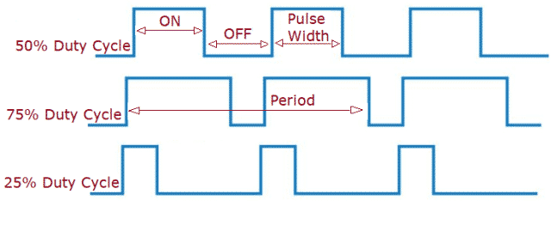Fig. 1 – Pulse Width Modulation (PWM) Waveforms
Fig.1 above shows Pulse Width Modulation Waveforms with different duty cycles. The proportion of time that the pulse is ‘ON’ or ‘High’ is called the Duty Cycle.
It is expressed as a percentage using the equation:
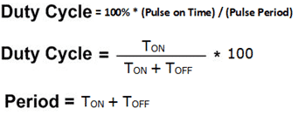
The ‘average’ voltage can be controlled by varying the width of the positive pulse. By varying or ‘modulating’ the Time that the output is “ON” we can modify the average voltage. The average value depends on the duty cycle. Smaller the “ON” time, lesser is the average value and similarly larger the “ON” time, higher is the average value.
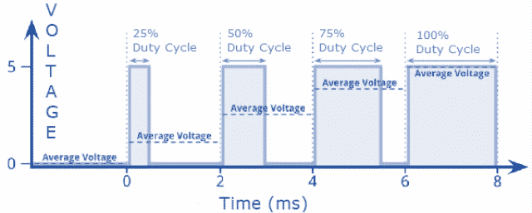
Fig. 2 – Representation of Average Voltages for PWM Waveforms

Types of Pulse Width Modulation (PWM) Techniques
There are three conventional types of PWM techniques namely:
- Lead Edge Modulation
- Trail Edge Modulation
- Pulse Center Two Edge Modulation/Phase Correct PWM

Lead Edge Modulation
In this technique, the lead edge of the signal is fixed and the trail edge is modulated.

Trail Edge Modulation
In this technique, the lead edge of the signal is modulated keeping the trail edge fixed.

Pulse Center Two Edge Modulation/Phase Correct PWM
In this method, the pulse center is fixed and both edges of the pulse is modulated.
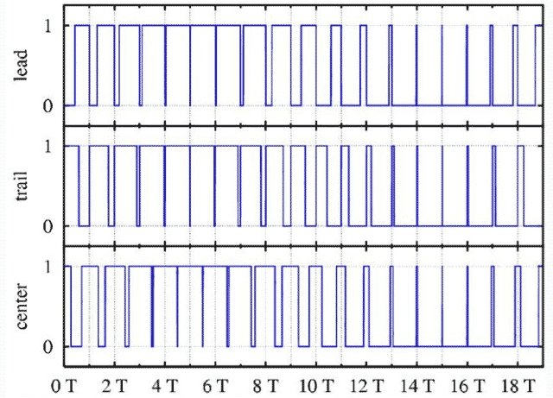
Fig. 3 –Types of Pulse Width Modulation Techniques

Generation of Pulse Width Modulation (PWM) Signal
Pulse Width Modulating signal can be generated using a Comparator as shown in the figure 4 (A). Modulating signal forms one of the input to the Comparator and the other input is fed with a non-sinusoidal wave or sawtooth wave. It operates at carrier frequency. The Comparator compares the two signals and generates a PWM signal as its output waveform.
If the value of the Sawtooth triangle signal is more than the modulation signal then the PWM output signal is at “High” else it’s in “Low” state. Thus, the value of the input signal magnitude determines the comparator output which defines the width of the pulse generated at the output.
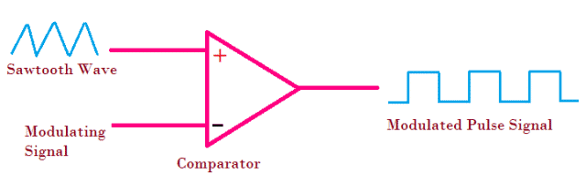
Fig. 4 – Generation of PWM Signal

Applications of Pulse Width Modulation (PWM)
The applications include:
- PWM Techniques are used in Telecommunications for encoding purposes.
- Pulse Width Modulation helps in voltage regulation and thus finds its use in controlling Brightness in Smart Lighting Systems and also controls the speed of motors.
- Computer Motherboard requires PWM Signals that controls the heat generated in the board. 4 Pin PWM header is embedded in the fan that helps to dissipate the heat from the motherboard.
- It is also used in Audio/Video Amplifiers.

Advantages of Pulse Width Modulation (PWM)
The advantages are:
- PWM technique helps in preventing overheating of LED’s while maintaining its brightness.
- Pulse Width Modulation provides accuracy and quick response time.
- It provides high input Power Factor.
- Initial cost is low.
- PWM technique helps the motors to generate maximum torque even when they are running at lower speeds.

Disadvantages of Pulse Width Modulation (PWM)
The disadvantages are:
- As the PWM frequency is high, switching losses is considerably high.
- It induces Radio Frequency Interference (RFI).
Also Read:
Instrumentation Amplifier – Working Principle, Applications, Advantages
How Electronic Voting (e-Voting) Works – Types, Application & Advantage
What is Fuse – Symbols, Features, Types, Applications & Advantages

Laxmi Ashrit
Laxmi is a B.E (Electronics & Communication) and has work experience in RelQ Software as Test Engineer and HP as Technical support executive. She is an author, editor and partner at Electricalfundablog.

